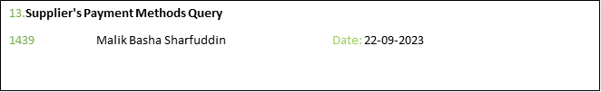

GIVEN Query

1)Supplier's Payment Methods

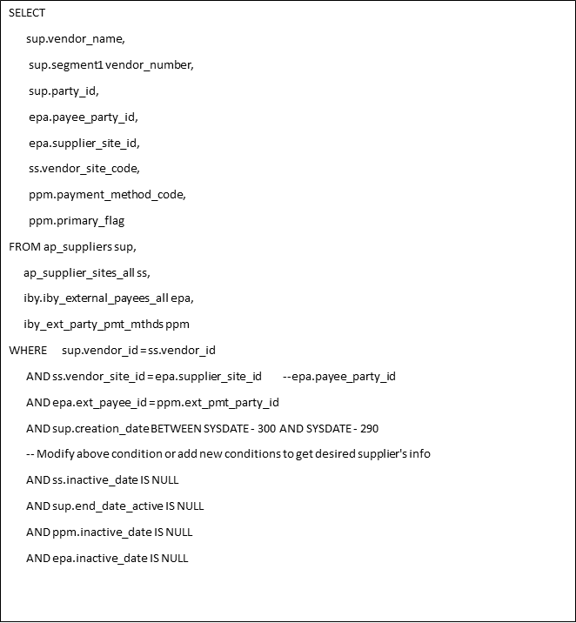

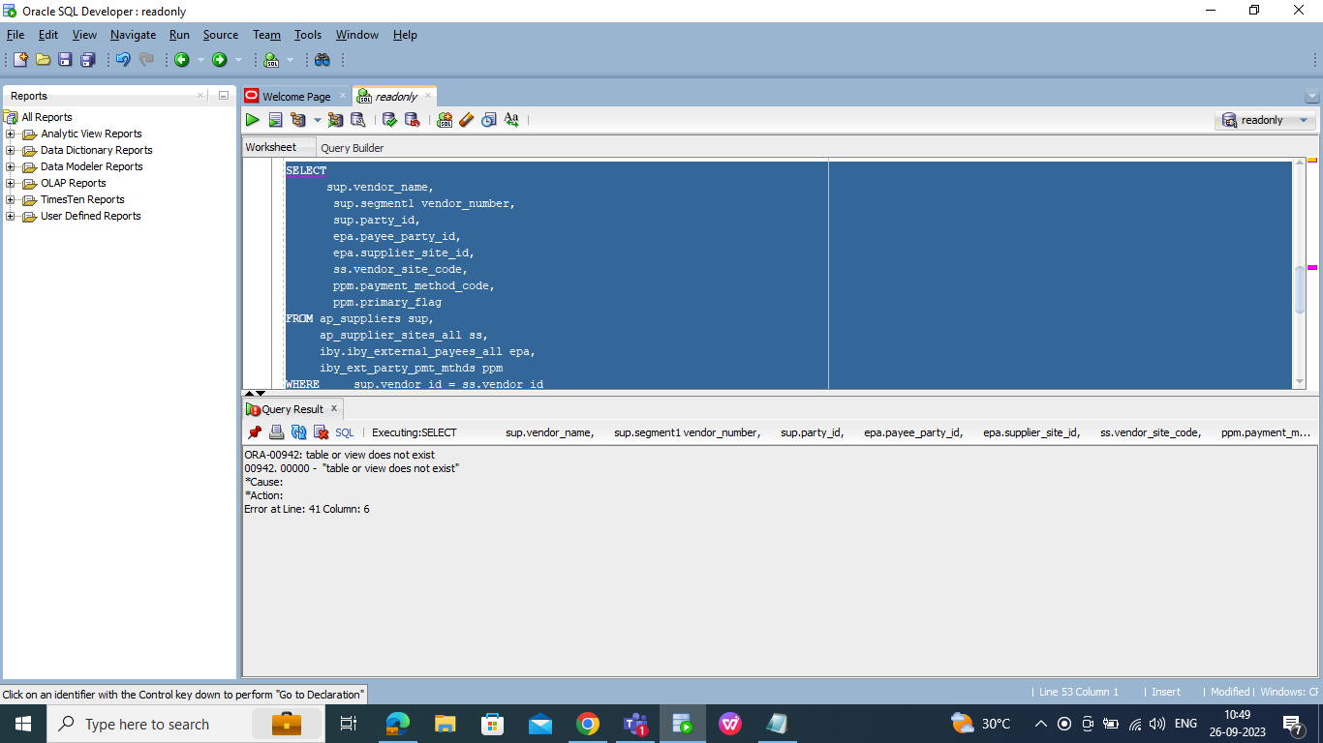

AND sup.creation_date BETWEEN SYSDATE - 300 AND SYSDATE – 290

This condition was originally in your query and likely caused an error.

Query Without the Date Range Condition:

After removing the above condition, the query started working. This suggests that the issue was likely related to how the date range was specified.

Usage of "apps schema":

You mentioned that you used the "apps schema" for your tables. This indicates that you're working within the context of Oracle E-Business Suite or a similar Oracle application where the schema name is typically "APPS".

SELECT

sup.vendor_name,

sup.segment1 vendor_number,

sup.party_id,

epa.payee_party_id,

epa.supplier_site_id,

ss.vendor_site_code,

ppm.payment_method_code,

ppm.primary_flag

FROM apps.ap_suppliers sup,

apps.ap_supplier_sites_all ss,

apps.iby_external_payees_all epa,

apps.iby_ext_party_pmt_mthds ppm

WHERE

sup.vendor_id = ss.vendor_id

AND ss.vendor_site_id = epa.supplier_site_id

AND epa.ext_payee_id = ppm.ext_pmt_party_id

AND ss.inactive_date IS NULL

AND sup.end_date_active IS NULL

AND ppm.inactive_date IS NULL

AND epa.inactive_date IS NULL

**Output:**

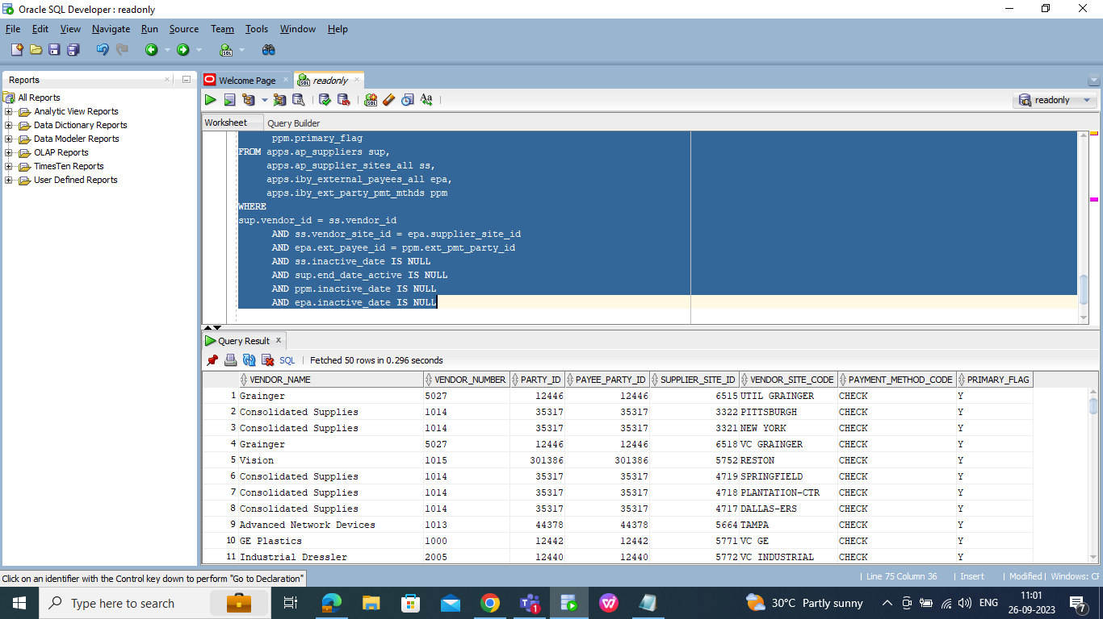

**3)EXPLAINATION:**

Added a new condition to your SQL query

**AND sup.creation_date BETWEEN TO_DATE('1997-02-24 03:01:19', 'YYYY-MM-DD HH24:MI:SS')**

**In these supplier creation date I used data funtion to display one date to another**

**SELECT**

**sup.vendor_name,**

**sup.segment1 vendor_number,**

**sup.party_id,**

**epa.payee_party_id,**

**epa.supplier_site_id,**

**ss.vendor_site_code,**

**ppm.payment_method_code,**

**ppm.primary_flag**

**FROM apps.ap_suppliers sup,**

**apps.ap_supplier_sites_all ss,**

**apps.iby_external_payees_all epa,**

**apps.iby_ext_party_pmt_mthds ppm**

**WHERE**

**sup.vendor_id = ss.vendor_id**

**AND ss.vendor_site_id = epa.supplier_site_id**

**AND epa.ext_payee_id = ppm.ext_pmt_party_id**

**AND sup.creation_date BETWEEN TO_DATE('1997-02-24 03:01:19', 'YYYY-MM-DD HH24:MI:SS')**

**AND TO_DATE('2004-09-01 07:19:03', 'YYYY-MM-DD HH24:MI:SS')**

**AND ss.inactive_date IS NULL**

**AND sup.end_date_active IS NULL**

**AND ppm.inactive_date IS NULL**

**AND epa.inactive_date IS NULL**

**Output:**

